ARYAMAN MISHRA 19BCE1027

1)SERVER

#include<stdio.h>

#include<sys/types.h>

#include<netinet/in.h>

#include<string.h>

#include<unistd.h>

#include<stdio.h>

#include<sys/types.h>

#include<netinet/in.h>

#include<string.h>

#include<unistd.h>

#include <time.h>

int main()

{

int sd,sd2,nsd,clilen,sport,len,port;

char sendmsg[100],revmsg[100];

time_t ticks;

struct sockaddr_in servaddr,cliaddr;

printf("Enter server port\n");

scanf("%d",&sport);

sd=socket(AF_INET,SOCK_STREAM,0);

if(sd<0)

printf("Can't Create \n");

else

printf("Socket is Created\n");

servaddr.sin_family=AF_INET;

servaddr.sin_addr.s_addr=htonl(INADDR_ANY);

servaddr.sin_port=htons(sport);

sd2=bind(sd,(struct sockaddr*)&servaddr,sizeof(servaddr));

if(sd2<0)

printf("Can't Bind\n");

else

printf("\n Binded\n");

listen(sd,5);

clilen=sizeof(cliaddr);

nsd=accept(sd,(struct sockaddr*)&cliaddr,&clilen);

if(nsd<0)

printf("Cant accept \n");

else

printf("Accept \n");

ticks=time(NULL);

strcpy(sendmsg,ctime(&ticks));

recv(nsd,revmsg,100,0);

printf("Message read %s\n",sendmsg);

fgets(sendmsg,100,stdin);

len=strlen(sendmsg);

sendmsg[len-1]='\0';

send(sd,sendmsg,100,0);

close(sd);

close(nsd);

}

CLIENT

#include<stdio.h>

#include<sys/types.h>

#include<netinet/in.h>

#include<string.h>

#include<unistd.h>

int main()

{

int csd,cport,len;

char sendmsg[100],revmsg[100];

struct sockaddr_in servaddr,cliaddr;

printf("Enter server port\n");

scanf("%d",&cport);

printf("%d\n",cport);

csd=socket(AF_INET,SOCK_STREAM,0);

if(csd<0)

printf("cant create\n");

else

printf("Socket is created\n");

servaddr.sin_family=AF_INET;

servaddr.sin_addr.s_addr=htonl(INADDR_ANY); //inet_addr("");

servaddr.sin_port=htons(cport);

if(connect(csd,(struct sockaddr*) &servaddr,sizeof(servaddr))<0)

printf("cant connect\n");

else

printf("Connected\n");

fgets(revmsg,100,stdin);

len=strlen(sendmsg);

sendmsg[len-1]='\0';

send(csd,sendmsg,100,0);

recv(csd,revmsg,100,0);

printf("Message read %s\n",revmsg);

close(csd);

}

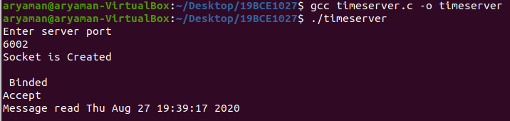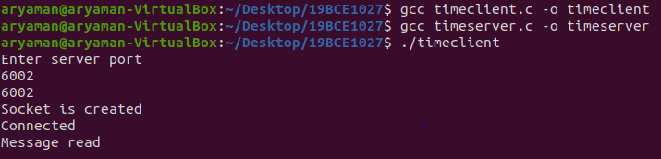

2)SERVER

#include<stdio.h>

#include<string.h>

#include<stdlib.h>

#include<sys/socket.h>

#include<sys/types.h>

#include<arpa/inet.h>

#include<netinet/in.h>

#include<netinet/ip.h>

#include<unistd.h>

int main()

{

system("clear");

int sendfd=socket(AF_INET,SOCK_DGRAM,IPPROTO_UDP);

if(sendfd==-1)

{

perror("Socket creation failed\n");

exit(0);

}

struct sockaddr_in server,client;

server.sin_family=AF_INET;

server.sin_port=htons(5000);

server.sin_addr.s_addr=INADDR_ANY;

char snd[200],rcv[200];

while(1)

{

printf("Enter message to receiver:");

scanf("%s",snd);

int size=sizeof(client);

sendto(sendfd,snd,strlen(snd),0,(struct sockaddr*)&server,sizeof(server));

int len=recvfrom(sendfd,rcv,sizeof(rcv),0,(struct sockaddr*)&client,&size);

rcv[len]='\0';

printf("Msg from receiver:%s\n",rcv);

}

close(sendfd);

}

CLIENT

#include<stdio.h>

#include<string.h>

#include<stdlib.h>

#include<sys/socket.h>

#include<arpa/inet.h>

#include<sys/types.h>

#include<netinet/in.h>

#include<netinet/ip.h>

#include<unistd.h>

int main()

{

system("clear");

int recevfd=socket(AF_INET,SOCK_DGRAM,IPPROTO_UDP);

if(recevfd==-1)

{

perror("Socket creation failed\n");

exit(0);

}

struct sockaddr_in server,client;

server.sin_family=AF_INET;

server.sin_port=htons(5000);

server.sin_addr.s_addr=INADDR_ANY;

int b=bind(recevfd,(struct sockaddr*)&server,sizeof(server));

if(b==-1)

{

perror("bind failue\n");

exit(0);

}

char rcv[200],snd[200];

while(1)

{

int size=sizeof(server);

int len=recvfrom(recevfd,rcv,sizeof(rcv),0,(struct sockaddr*)&client,&size);

rcv[len]='\0';

if(strcmp(rcv,"exit")==0)

break;

printf("Msg received form sender:%s\n",rcv);

printf("Enter msg to send to sender:");

scanf("%s",snd);

sendto(recevfd,snd,strlen(snd),0,(struct sockaddr*)&client,sizeof(client));

if(strcmp(snd,"exit")==0)

break;

}

close(recevfd);

}

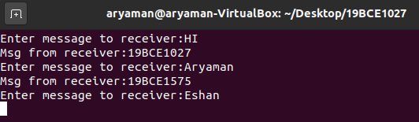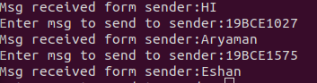

3)SERVER

#include <stdio.h>

#include <string.h>

#include <stdlib.h>

#include <sys/socket.h>

#include <sys/types.h>

#include <netinet/in.h>

#include <time.h>

int main()

{

int nsd,r,bi,port;

char b[1024];

struct sockaddr_in servaddr,cliaddr;

socklen_t clilen;

nsd=socket(AF_INET,SOCK_DGRAM,0);

if(nsd==-1)

{

perror("Socket");

return 0;

}

printf("Enter the port no:");

scanf("%d",&port);

printf("The port no is:%d\n",port);

servaddr.sin_family = AF_INET;

servaddr.sin_port = htons(port);

servaddr.sin_addr.s_addr = INADDR_ANY;

bi=bind(nsd,(struct sockaddr*)&servaddr,sizeof(servaddr));

if(bi==-1)

{

perror("Bind()");

return 0;

}

clilen = sizeof(cliaddr);

r=recvfrom(nsd,b,sizeof(b),0,(struct sockaddr*)&cliaddr,&clilen);

b[r]=0;

time_t ticks;

ticks = time(NULL);

snprintf(b,sizeof(b),"%s",ctime(&ticks));

sendto(nsd,b,sizeof(b),0,(struct sockaddr*)&cliaddr,sizeof(cliaddr));

exit(0);

return 0;

}

CLIENT

#include <stdio.h>

#include <string.h>

#include <stdlib.h>

#include <sys/socket.h>

#include <sys/types.h>

#include <netinet/in.h>

int main()

{

int listenfd,port,r;

char b[1024];

struct sockaddr_in servaddr,cliaddr;

socklen_t servlen;

listenfd = socket(AF_INET,SOCK_DGRAM,0);

if(listenfd==-1)

{

perror("Socket");

return 0;

}

printf("Enter the port no:");

scanf("%d",&port);

printf("The port no is:%d",port);

servaddr.sin_family = AF_INET;

servaddr.sin_port = htons(port);

servaddr.sin_addr.s_addr = INADDR_ANY;

sendto(listenfd,b,sizeof(b),0,(struct sockaddr*)&servaddr,sizeof(servaddr));

r=recvfrom(listenfd,b,sizeof(b),0,(struct sockaddr*)&servaddr,&servlen);

b[r]=0;

printf("\nThe time received from the server:%s\n",b);

exit(0);

return 0;

}

